Title: | Intro to Git and GitHub
Updated: | April 3, 2025 | Due Date: | Midnight before the next class meeting.
Purpose: | The purpose of this lab is to introduce you to Git and GitHub, providing hands-on experience in installing Git, creating and managing repositories, committing changes, and using version control systems to organize and track project files effectively.
Knowledge: | After completing this lab, you will understand how to use Git for version control, including installing Git, initializing repositories, committing changes, and managing project files through GitHub.
Task/Activity: | A. Git Installation  B. Create a Repository  C. Committing Changes  D. Project Setup  E. Reflection
Criteria for Success: | Success in this lab is marked by accurate task completion, effective analysis, documentation, and clear communication of findings. A crucial aspect involves reflecting on the purpose of the lab, linking procedures to broader concepts, and recognizing the lab's significance within the course.  Overall, success is not only measured by technical proficiency but also by critical thinking, effective communication, and a reflective summary that captures the challenges faced and insights gained throughout the lab experience.
- Git Installation
Git is a very important tool used by developers to keep code, files, and almost anything else, in sync between their local development environment (local computer) to a remote server (on the internet, or on a local network server). Git is a type of tool called a Version Control System. Version Control Systems are used to keep track of each version, or change, of a file. This allows users to go back to a point in time with their code, or to manage the differences between two different versions of a file if multiple people have worked on it.
To use Git, it will need to be installed on the computer you are using it on.
- Navigate to https://git-scm.com/downloads and download the version of git for your platform. Most of you will download the Windows version. Perform a “push-through” install of Git, accepting all the default options.
Note: If you are on Linux or MacOS, you can install it from the command line.
# sudo dnf install git – RedHat, CentOS, AlmaLinux, and variants
# sudo apt install git – Ubuntu and variants
# brew install git – MacOS (with Homebrew installed)
- Once Git is installed, we need to configure a couple of settings to allow you to use it to make your first repository. A repository is where your project’s files and history are stored. Inside of VS Code, press “CTRL + `” The ` is the key to the left of the 1 key on most keyboards.
# git config –-global user.name “Your Name”
# git config –-global user.email “youremail@students.westerntc.edu”
Note: Be sure to update the “Your Name” and “youremail@” sections with your name and student email account.

Commands | # git config --global user.name “Daniela Gonzalez”  #git config --global user.email “gonzalezd@students.westerntc.edu”
Screenshot | 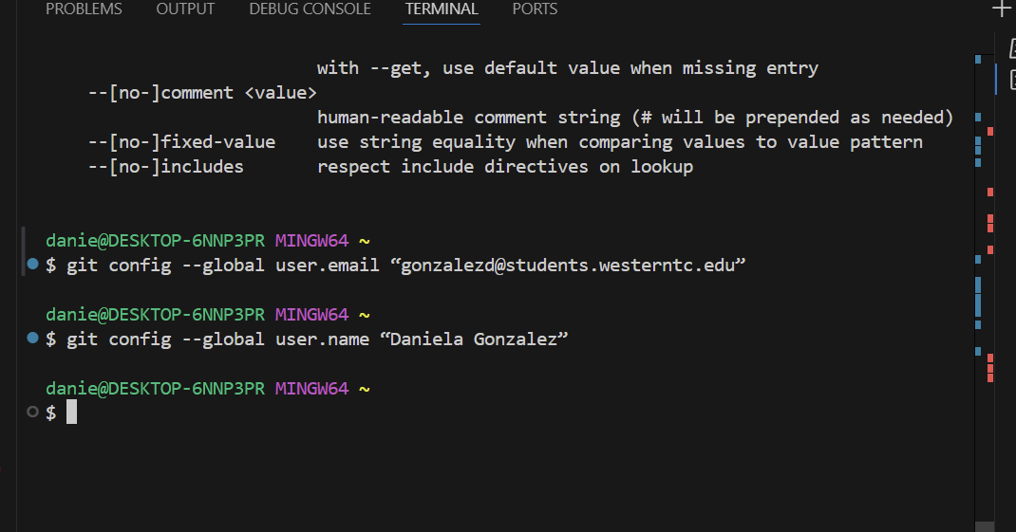
- Create a Repository
A repository is a location where your project’s files and history are stored. For each project, you should create a separate repository. For example, if you are making a web app and a mobile phone app, you should create two repositories, one for each project. This keeps your code neatly organized and allows others to be given access just to the projects that you want them working on, and not everything on your computer.
The following steps should be completed in Visual Studio Code (VSCode) in the Terminal window. To open the Terminal window, click “Terminal” in the menu bar, and select “New Terminal.”
- Create a folder called “devops” with a subfolder called “lab1,” then navigate into the folder:
In Windows, type:
C:\> mkdir devops\lab1
C:\> cd devops\lab1
In MacOS and Linux:
# mkdir -p devops/lab1 ßThe -p allows us to create both directories at once
# cd devops/lab1
Command | Mkdir devops\lab1  Cd devops\lab1
Screenshot | 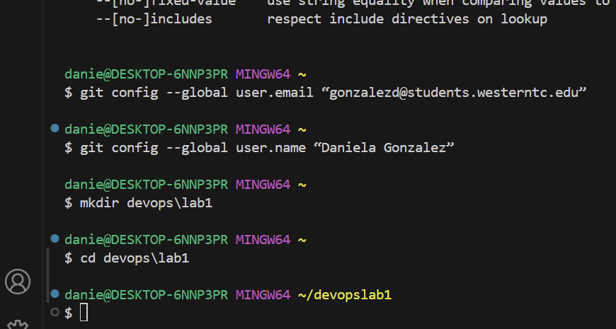
- To create a repository, it needs to be “initialized.” To initialize your first repository, navigate to the folder that you want to create your repository from and run the init command:
# git init
This creates a hidden .git folder in the folder where you ran the init command. This folder stores the version history of your files.
Command | Git init
Screenshot | 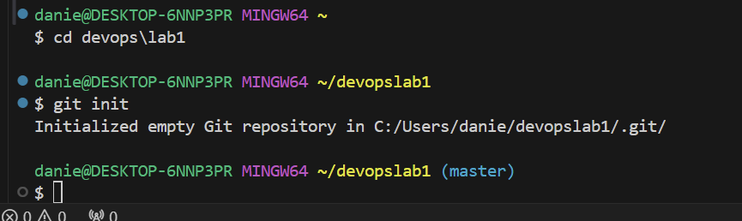
- In addition to creating a new repository, you can also “clone” an existing repository. To do so, you can use the git clone command:
# git clone {web address to repository}
- Now that you have the repo setup, we need to add files that will be tracked by Git to the repo. To do this, we will use the git add command:
# git add . ß This will add everything in the folder where you ran this command
Command | Git add .
Screenshot | 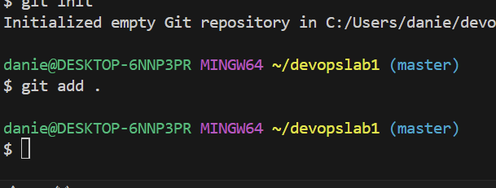
# git add filename.ext ß This will add a specific file
At this point, you have created a repo and added either a selection of files, or all the files in a folder to it. Code away and make any updates, additions, or changes to the files. We will add any changes and update the repo in the next step.
- Committing Changes
One of the things you will do most often with git is commit changes that you have made. This is done with the git commit command. However, there is another step. With each commit, a message must be added. This message is usually a very short summary of what was changed between this and the last commit.
- Lets create a file called TOC.MD in our lab1 folder and open it in VSCode:
# code -r TOC.MD
- Inside of the new file, add the following text exactly as written:
Table of Contents
1 Beginning
2 Middle
3 End
- Save the file.
- Run the git add command to add this new file to our repo:
# git add TOC.MD
Or
# git add .
- Run the following command to commit the changes. Note: You will get more explanation of this command in the next step.
# git commit -m “initial files”
This has updated the repository with the new files we just created and modified.
- Update the file with some markdown (changes highlighted in yellow for ease):
# Table of Contents
1. Beginning
2. Middle
3. End
I might make my git commit message read “Added markdown to table of contents.” To do this, I would use the following command:
# git add .
# git commit -m “Added markdown to table of contents”
Now that I have committed changes, I can review the history of any changes by using the git log command:
# git log
commit 24c7808d17cb949c54851a03c543e97b7876e029 (HEAD -> master)
Author: Tage Bushman <bushmant@westerntc.edu>
Date: Mon Sep 16 15:14:49 2024 -0500
Added markdown to table of contents
This shows the list of commits that have been made, along with messages and IDs.
- Project Setup
Now that we have the basics of Git down, we can start a new repository that we will use for the next couple of labs. For each step, please provide the command that you used, along with a screenshot showing the output of the command. You can type the commands and complete the coding inside of Visual Studio Code. Once in VS Code, you can access the terminal with the keyboard command “CTRL + `.” The ` is the key to the left of the 1 key on most keyboards.
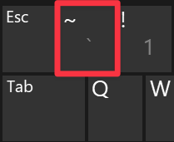
- Create a folder in the devops folder called “Markdown Basics.”
C:\> cd .. ß This is the command to go “up” a folder in Windows
# cd .. ß And in Linux
Note: To make a folder with a space in it, you must surround it with quotes (“).
Command | Mkdir ”Markdown Basics”
Screenshot | 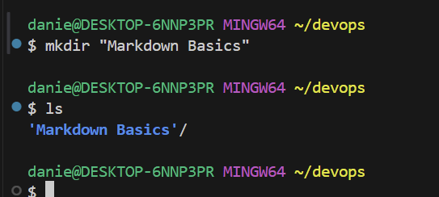
- Use Git to initialize a repo for that folder.
Command | Git init
Screenshot | 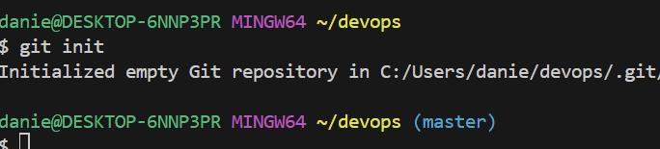
- Add all the files in the folder to the repo.
Command | Git add .
Screenshot | 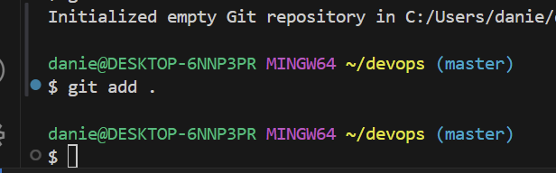
- Create a file called README.MD in the Markdown Basics folder.
Command | Cd “Markdown Basics”  Code README.MD
Screenshot | 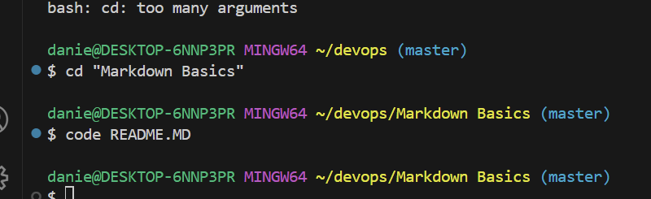
- Inside the README.MD file, add text and markdown code to replicate the image below:
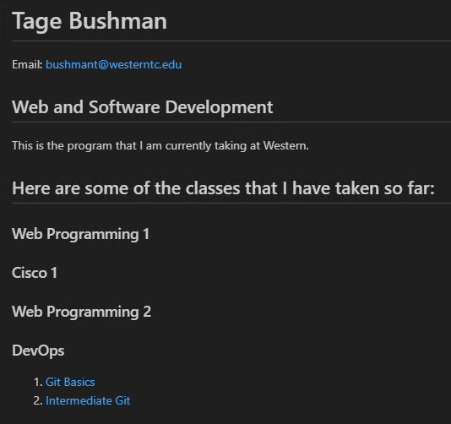
Code: | # Daniela Gonzalez #  Email: <gonzalezd@students.westerntc.edu>  ## Web and Software Development ##  This is the program that i am currently taking at Western  ## Here are some of the classes that I have taken so far: ##  ### Web Programming 1 ###  Cisco 1  ### Web Programming 2 ###  ### DevOps ###  1. [Git Basics]()  2. [Intermediate Git]()
Screenshot: | 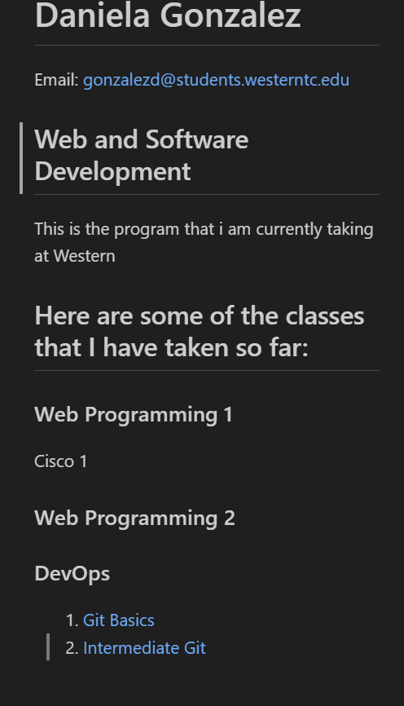
- Commit the new file to the repo with the comment “Beginning of my markdown documentation.”
Command: | Git add .  Git commit –m “Beginning of my markdown documentation”
Screenshot: | 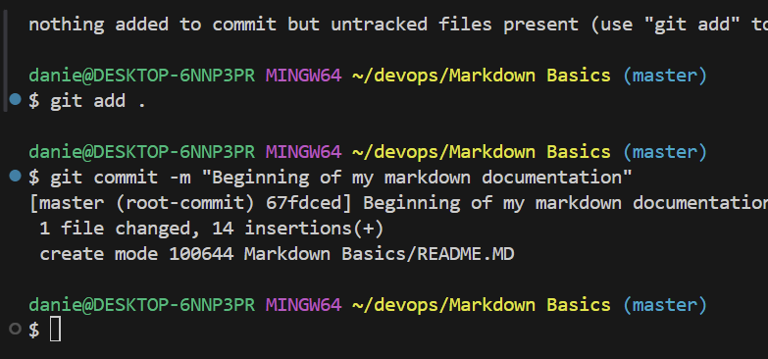
- Reflection
- Reflect on your experience with Git and GitHub during this lab. What challenges did you face while installing Git, creating repositories, and committing changes? How do you think these skills will help you in managing projects in the future? Consider how version control can improve collaboration and project organization.
Originally, I struggled with how to even create the folders and files in Git but thankfully after a few errors and guidance I feel better about handling the repository creation in Git. I especially enjoy coding in markdown, I find it to be fairly simple and fun. I also realize that I struggle with the syntax, so I need to be better at checking how I input the code.

